**Canine Parainfluenza Virus Ag Rapid Test**

**Cat No.: H81006**

1. **INTENDED USE**

Chemicos™ Canine Parainfluenza Virus Ag Rapid Test is a sandwich lateral flow immunochromatographic assay for the qualitative detection of canine Parainfluenza virus (CPIV Ag) in dog’s secretions.

**Assay Time:**  5 - 10 min

**Sample:** ocular or nasal secretions

1. **PRINCIPLE OF THE ASSAY**

Chemicos™ Canine Parainfluenza Virus Ag Rapid Test is based on sandwich lateral flow immunochromatographic assay. The test device has a testing window. The testing window has an invisible T (test) zone and C (control) zone. When sample is applied into the sample hole on the device, the liquid will laterally flow on the surface of the test strip. If there is enough Parainfluenza antigen in the sample, a visible T band will appear. The C band should always appear after a sample is applied, indicating a valid result. By this means, the device can accurately indicate the presence of Canine Parainfluenza antigen in the sample.

1. **KIT COMPONENT**

* 20×foil pouches, each containing a cassette and desiccant
* 20×assay buffer
* 20×swab sticks
* Product Manual

1. **TEST PROCEDURE**

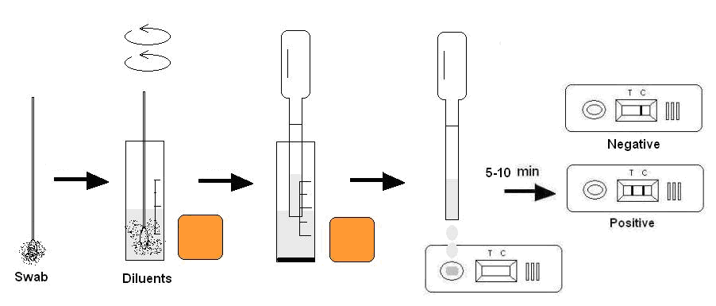

* Collect dog’s ocular or nasal secretions with the swab stick. Make the swab wet sufficiently.
* Insert the wet swab into the provided assay buffer tube. Agitate it to assure good sample extraction.
* Take out the cassette from the foil pouch and place it horizontally.
* Gradually drip 3 drops of sample extraction into the sample hole.
* Interpret the result in 5 - 10 minutes. Result after 10 minutes is only considered as reference.

1. **INTERPRETATION OF RESULTS**

**Positive**: The presence of both C band and T band, no matter T band is clear or vague.

**Negative:** Only clear C band appears.

**Invalid:** No colored band appears in C zone, no matter whether T band appears.

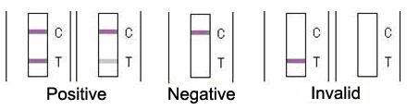

1. **STORAGE**

The kit can be stored at room temperature (2-30°C). The test kit is stable through the expiration date (24 months) marked on the foil pouch. **DO NOT FREEZE**. Do not store the test kit in direct sunlight.

1. **PRECAUTIONS**

* For best results, please strictly adhere to these instructions.
* All reagents must be at room temperature before running the assay.
* Do not remove test cassette from its pouch until immediately before use.
* Do not reuse the test kit.
* Do not use the test beyond its expiration date marked on the foil pouch.
* The components in this kit have been quality control tested as standard batch unit. Do not mix components from different lot numbers.

1. **LIMITATION**

Chemicos™ Canine Parainfluenza Virus Ag Rapid Test is for in vitro veterinary diagnosis use only. All results should be considered with other clinical information available from veterinarian. For an accurate result, It is suggested to apply other method such as PCR for final determination in practice.