**Feline Corona Virus Ag Rapid Test**

**Cat No.: H81025**

1. **INTENDED USE**

Chemicos™ Feline CoronaVirus Ag Rapid Test is a sandwich lateral flow immunochromatographic assay for the qualitative detection of FIP-triggerred Corona virus antigen(FCoV Ag) in cat’s feces, serum and ascites.

**Assay Time:**  5 - 10 min

**Sample:** Mixture of serum and feces extraction, ascites.

1. **PRINCIPLE OF THE ASSAY**

Chemicos™ FelineCorona Virus Ag Rapid Test is based on sandwich lateral flow immunochromatographic assay. The test device has a testing window. The testing window has an invisible T (test) zone and C (control) zone. When sample is applied into the sample hole on the device, the liquid will laterally flow on the surface of the test strip. If there is enough FCoV antigen in the sample, a visible T band will appear. The C band should always appear after a sample is applied, indicating a valid result. By this means, the device can accurately indicate the presence of Feline Infectious Peritonitis triggerred Coronavirus in the sample.

1. **KIT COMPONENT**

* 20×foil pouches, each containing a cassette and desiccant
* 20×assay buffer
* 20×swab sticks
* Product Manual

1. **TEST PROCEDURE**

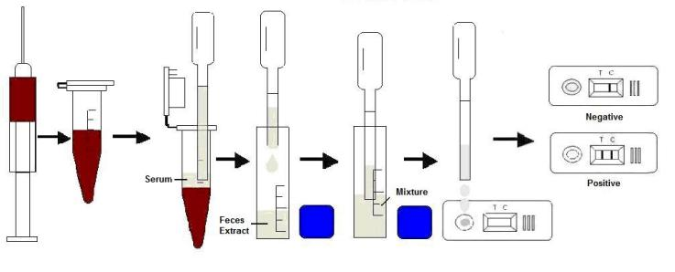

* Collect samples separately from fresh feline feces (liquid part), serum(1 drop), and cat’s ascites (if possible) into the diluents tube. Shake the tube sufficiently to mix them well.
* Take out the cassette from the foil pouch and place it horizontally.
* Gradually drip 3 drops of sample extraction into the sample hole.
* Interpret the result in 5 - 10 minutes. Result after 10 minutes is only considered as reference.

1. **INTERPRETATION OF RESULTS**

**Positive**: The presence of both C band and T band, no matter T band is clear or vague.

**Negative:** Only clear C band appears.

**Invalid:** No colored band appears in C zone, no matter whether T band appears.

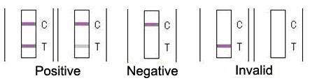

1. **STORAGE**

The kit can be stored at room temperature (2-30°C). The test kit is stable through the expiration date (24 months) marked on the foil pouch. **DO NOT FREEZE**. Do not store the test kit in direct sunlight.

1. **PRECAUTIONS**

* For best results, please strictly adhere to these instructions.
* All reagents must be at room temperature before running the assay.
* Do not remove test cassette from its pouch until immediately before use.
* Do not reuse the test kit.
* Do not use the test beyond its expiration date marked on the foil pouch.
* The components in this kit have been quality control tested as standard batch unit. Do not mix components from different lot numbers.

1. **LIMITATION**

Chemicos™ Feline Corona Virus Ag Rapid Test is only an auxiliary tool for determining the FIP disease. It is used to detect the FIP-triggerred Coronavirus and can only be considered as an in vitro rapid diagnostic reference for veterinarians in practice. FIP is a complex immunity disorder disease and is very difficult to be detected out by only one method. Vets should also consider about the clinical symptoms in practice and results from other diagnostic tools to give a comprehensive judgement.